Database Design: Using MySQL and PHP to
Implement the Leasing luxury database System

This project is to use MySQL and PHP to implement the RBMS application. In this case, you will design a relational database for a business that leases designer handbags. After your database design is completed and correct, you will create database tables and populate them with data. Customers will rent the handbags on your website. So you will produce a website will display the handbags available for rent by designer type and with some queries and reports. The queries will address the following questions: What handbags are available by a specified designer? How many handbags from each designer are in inventory? How many days has each customer leased handbags? Your reports will display the handbags available for rent by designer type and the amount of money each customer has spent leasing different handbags.
本项目将使用MySQL和PHP来实现RBMS应用程序。在这种情况下，您将为租赁名牌手提包的企业设计一个关系数据库。数据库设计完成并正确后，将创建数据库表并用数据填充它们。顾客会在你的网站上租用手提包。因此，你将制作一个网站，显示可供出租的手袋按设计师类型和一些查询和报告。这些问题将解决以下问题：指定设计师可以提供哪些手提包？每个设计师有多少手提包库存？每位顾客租用手提包多少天？您的报告将按设计师类型显示可供租赁的手提包，以及每位客户租赁不同手提包的花费。

1.BACKGROUND

Consumers love luxurious products, but they often cannot afford to buy luxury. Your Aunt Mabel has started a company to address this problem; her new company leases expensive handbags to women. Aunt Mabel owns a large number of designer handbags, and several years ago she began to lend them out to friends for special occasions. After several friends offered to pay her for the “loan” of the handbag, Mabel realized that she could offer a valuable service to women who want an expensive designer handbag for an evening out, a wedding, or other formal event. Leasing Luxury, or LL as it is commonly known, operates in the Atlanta area. The company model is simple: The daily cost of renting a handbag is set at a certain amount, depending on the designer. For example, a Coach bag rents for $9 per day, shipping included. Customers can keep a bag as long as they like, but they continue to pay the daily fee. Optional insurance costs an extra $1 per day; the insurance covers any damage to the expensive bags.
消费者喜爱奢侈品，但他们往往买不起奢侈品。你的梅布尔阿姨已经成立了一家公司来解决这个问题；她的新公司把昂贵的手提包租给妇女。梅布尔阿姨拥有大量名牌手提包，几年前她开始在特殊场合把它们借给朋友。在几个朋友提出向她支付手提包的“贷款”后，梅布尔意识到，她可以为那些想要在晚上外出、婚礼或其他正式活动中使用昂贵的名牌手提包的女性提供宝贵的服务。Leasing Luxury，简称LL，在亚特兰大地区运营。公司模式很简单：根据设计师的不同，每天租用一个手提包的费用是固定的。例如，Coach包的租金为每天9美元，包括运费。顾客可以保留一个袋子，只要他们喜欢，但他们继续支付每日费用。可选保险每天额外收费1美元；保险范围包括贵重袋子的任何损坏。
You have been hired to create a database to keep track of the available handbags, the customers who register for the service, and their bag rentals. The leasing payments are handled manually at this point. You have several goals for the database. First, you need to keep track of all the handbags that Aunt Mabel owns and that are available for leasing. She categorizes the bags by designer, type of bag, color for each bag.
你被雇来创建一个数据库，以跟踪可用的手提包、注册该服务的客户以及他们的包租赁情况。此时将手动处理租赁付款。数据库有几个目标。首先，你需要跟踪梅布尔阿姨拥有的所有可供租赁的手提包。她按设计师、包的类型、每个包的颜色对包进行分类。
Customer essentials need to be recorded as well. Aunt Mabel conducts the business on paper and via telephone, but she wants to move all work to the computer and Internet as soon as possible. Eventually, she would like customers to book their requests via a Web site.When customers register for the service, they provide their e-mail address, regular mailing address, and credit card number. (All transactions are conducted with credit cards.) Your database must record this leasing information for the handbags, along with the date rented, date returned, and whether the customer purchases damage insurance.
还需要记录客户的基本信息。梅布尔阿姨通过纸张和电话进行业务，但她想尽快将所有工作转移到电脑和互联网上。最终，她希望客户通过网站预订他们的请求。当客户注册该服务时，他们会提供他们的电子邮件地址、常规邮寄地址和信用卡号码。（所有交易都是用信用卡进行的。）您的数据库必须记录手提包的租赁信息，以及租赁日期、归还日期以及客户是否购买了损害保险。
As customers request handbags, Aunt Mabel and the other workers at LL would like to be able to fill out a form that lists each available bag and includes fields for the customer ID and leasing dates. Mabel would like to be able to enter this information directly into the database.
当顾客要求手提包时，Mabel阿姨和LL的其他员工希望能够填写一份表格，列出每个可用的袋子，并包括客户ID和租赁日期字段。Mabel希望能够将这些信息直接输入到数据库中。
Customers often visit the website to find what handbags are available by different designers. Mabel would like to be able to enter a designer’s name and then see a list of available bags by that designer.
顾客经常访问网站，了解不同设计师提供的手提包。Mabel希望能够输入设计师的姓名，然后查看该设计师的可用包包列表。
Mabel would like to understand the rental habits of her best customers, who she defines as the customers that keep the bags the longest time. Therefore, she would like to be able to calculate how long customers keep the bags, sorted by the longest duration to the shortest. She would also like to know how many bags she has for each type of designer. This information will be used for marketing purposes.
梅布尔想了解她最好的客户的租赁习惯，她将这些客户定义为保存袋子时间最长的客户。因此，她希望能够计算出顾客保存袋子的时间，按最长持续时间到最短持续时间排序。她还想知道每种类型的设计师有多少个包。这些信息将用于营销目的。

1. Building the database (15 points)

Use the SQL DDL statements to create the tables required for this project. Please also note that the tables are created in certain order such that by the time when a foreign key needs to be created, the corresponding primary key also need to be created.
使用SQL DDL语句可以创建此项目所需的表。还请注意，这些表是按一定顺序创建的，因此当需要创建外键时，也需要创建相应的主键。
(1) First, determine the tables you will need by listing the name of each table and the fields it
should contain. Avoid data redundancy. Do not create a field if it can be created by a calculated
field” in a query.
首先，通过列出每个表的名称及其应包含的字段来确定所需的表。避免数据冗余。如果字段可以由查询中的“计算字段”创建，则不要创建字段。
(2)You will need transaction tables (Rentals). Think about what business events occur with each customer’s transactions. Avoid duplicating data.
您将需要交易表（Rentals）。想想每个客户的交易会发生什么业务事件。避免重复数据。
(3)You must mark the appropriate primary key field(s) or foreign key field(s) for each table.
Keep in mind that each table might need a compound primary key to uniquely identify a record within a table.
必须为每个表标记相应的主键字段或外键字段。
请记住，每个表可能需要一个复合主键来唯一标识表中的记录。
(4) Enter at least 10 records for handbags from four different designers.
输入来自四位不同设计师的手提包的至少10项记录。
(5) Enter records for at least eight customers, including their names, addresses, telephone numbers,
e-mail addresses, and fictional credit card numbers. Enter your own name and information as an
additional customer.
输入至少八位客户的记录，包括他们的姓名、地址、电话号码，电子邮件地址和虚构的信用卡号。输入您自己的姓名和信息作为额外的客户。
(6)Each handbag should be rented at least once. Each customer should rent a handbag twice.Appropriately limit the size of the text fields; for example, a telephone number does not need
the default length of 255 characters.
每个手提包至少要租一次。每位顾客应租用一个手提包两次。适当限制文本字段的大小；例如，电话号码不需要默认长度为255个字符。

2. MySQL Implementation (55 points)

You need to write SQL queries, stored procedures/functions, and triggers to implement this project. The following requirements and functionalities need to be implemented.
您需要编写SQL查询、存储过程/函数和触发器来实现此项目。需要实现以下要求和功能。
- (7 points) Write a stored procedure Bags by Manufacturer that inputs for the designer name and then lists the name of the bag and its color. In the example shown in table 1, the manufacturer name is Coach. Your output should resemble that shown in table 1, although your data will be different.
编写一个存储程序“按制造商分组”，输入设计师名称，然后列出袋子的名称及其颜色。在表1所示的示例中，制造商名称为Coach。您的输出应该与表1中所示的类似，尽管您的数据会有所不同。
Table 1 Bags by Manufacturer
Bags by Manufacturer
Name | Color | Manufacturer
Satchel | Camel | Coach
Hippie Flap | Green | Coach
Bleeker Bucket | Blue | Coach

- (8 points) Write a stored procedure called Best Customers that calculates and adds the rental times of all handbags by each customer. The query should include columns for Last Name, First Name, Address, Telephone, and Total Length of rental. Your output should look like that in table 2, although your data will be different.
编写一个名为“最佳客户”的存储过程，计算并添加每个客户所有手提包的租赁时间。查询应包括“姓氏”、“名字”、“地址”、“电话”和“租赁总时长”列。您的输出应该如表2中所示，尽管您的数据会有所不同。
Table 2 Best Customers
Best Customers
Last Name | First Name | Address | Telephone | Total Length of Rentals
Zern | Joan | 58 W. Central Ave | 404-675-0091 | 40
Murray | Annabelle | 59 W. Central Ave | 404-998-3928 | 31
Smith | Patricia | 1700 E. Lincoln Ave | 404-765-3342 | 28
Berry | Anna | 9 Pleasant Way | 404-887-4673 | 28
Franco | Gina | 1012 Peachtree St | 404-887-2342 | 14
Pao | Jill | 89 Orchard | 404-887-9238 | 13
Lopato | Maria | 5490 West 5th | 404-234-8876 | 7
Quinn | Sally | 54 Oak Ave | 404-987-3427 | 1

- (7 points) Write a procedure to calculate and list the amount of money each customer is spending. The amounts will account for the number of days the bag has been rented. For example, you can use a procedure, say report_customer_amount(customer_id), for this operation.
写一个程序来计算并列出每个客户的消费金额。这些金额将说明袋子被租用的天数。例如，您可以为此操作使用一个过程，例如report_customer_amount（customer_id）。
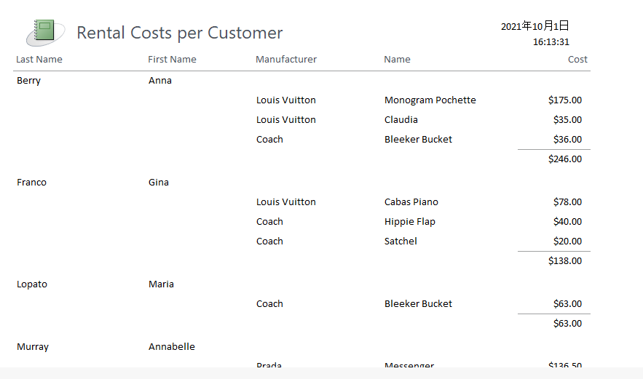

- (8 points) Write two procedures add tuples into the Rentals table and the bags table. As an example, you can use a procedure, say add_rentals to add a tuple in the Rentals table, where Customer ID,Bag ID,Date_Rented Date_Returned etc are parameters of the procedure. Note that Date Rented should be the current time (use current_timestamp).
编写两个过程，将元组添加到Rentals表和bags表中。例如，您可以使用一个过程，例如add_rentals，在rentals表中添加一个元组，其中Customer ID、Bag ID、Date_Rended Date_Return等是该过程的参数。请注意，租用日期应为当前时间（使用current_timestamp）。
- (15points) If a bag is returned, your program should perform the following tasks: (1) print a message indicating the total length of rental and the total amount of money, (2) make the bag is available to rent again. Use triggers to implement the tasks.
如果行李被退回，您的程序应执行以下任务：（1）打印一条消息，指示租赁的总长度和总金额，（2）使行李可以再次租赁。使用触发器来执行任务。
- (10points) You need to make your code user friendly by designing and displaying appropriate messages for all exceptions. For example, if someone wants to find the purchases of a customer but entered a non-existent customer id, your program should report the problem clearly.
您需要通过为所有异常设计和显示适当的消息，使代码对用户友好。例如，如果有人想找到一个客户的购买，但输入了一个不存在的客户id，您的程序应该清楚地报告问题。

3. Interface (20 points)

Implement a Web interactive interface using PHP 、JavaScript etc . Your interface program should utilize as many of your MySQL stored procedures/functions as possible.
使用PHP、JavaScript等实现Web交互界面。您的接口程序应该尽可能多地使用MySQL存储过程/函数。

4. Documentation (10 points)

Documentation consists of the following aspects:

- Each procedure and function and every other object you create for your project needs to be explained clearly regarding its objective and usage.
- Your code needs to be well documented with in-line comments.
文档包括以下几个方面：
1.你为项目创建的每一个过程和功能以及每一个其他对象都需要清楚地解释其目标和用途。
2.您的代码需要有良好的文档记录和在线注释。

5. Hand-ins, Demo and Grading

- You will also need to submit your source code along with your documentation to the Blackboard.
- It is required to demonstrate your project to the instructor using tuples created by the instructor.
- The grading will be based on the quality of your code, the documentation and on how successful of your demo is.
1.您还需要将源代码和文档一起提交到黑板。
2.要求使用讲师创建的元组向讲师演示您的项目。
3.评分将基于代码的质量、文档以及演示的成功程度。

